**API TESTING**

* Creating an account in weather rest API <https://openweathermap.org/api>

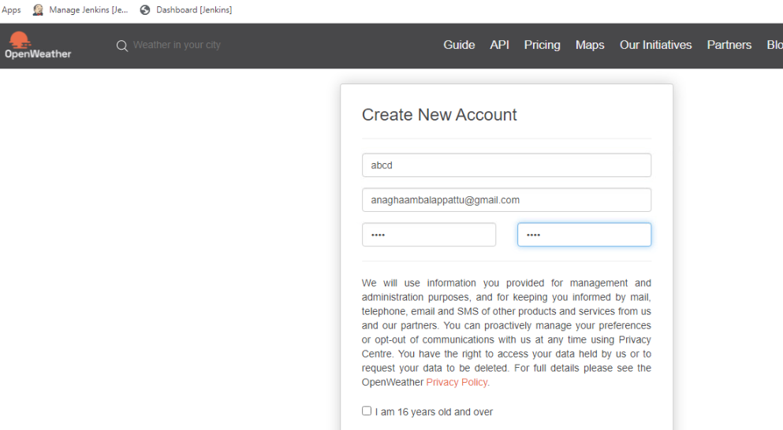

* <https://openweathermap.org/current>

api.openweathermap.org/data/2.5/weather?q={city name}&appid=[{API key}](https://home.openweathermap.org/api_keys)

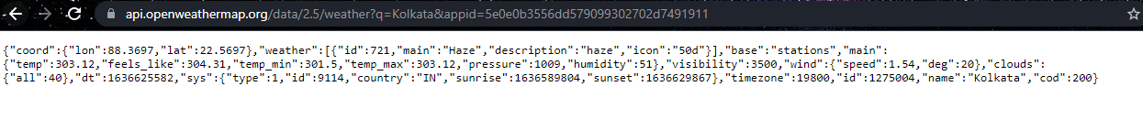

* Now Open JMeter 🡪 Create new thread 🡪 thread group
* Add 🡪 Http Request.
* Add 🡪 Listener 🡪 View Result Tree
* Run & Obtain the result.

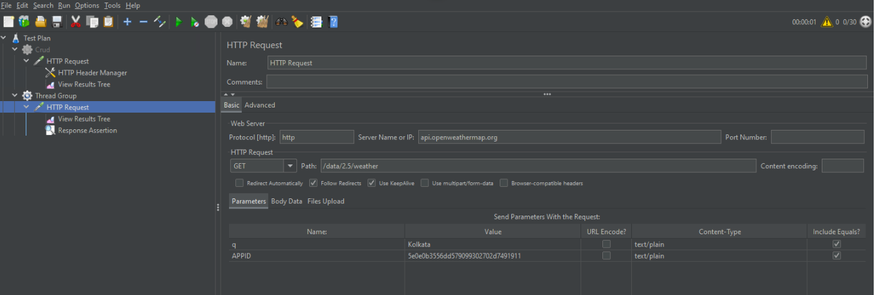

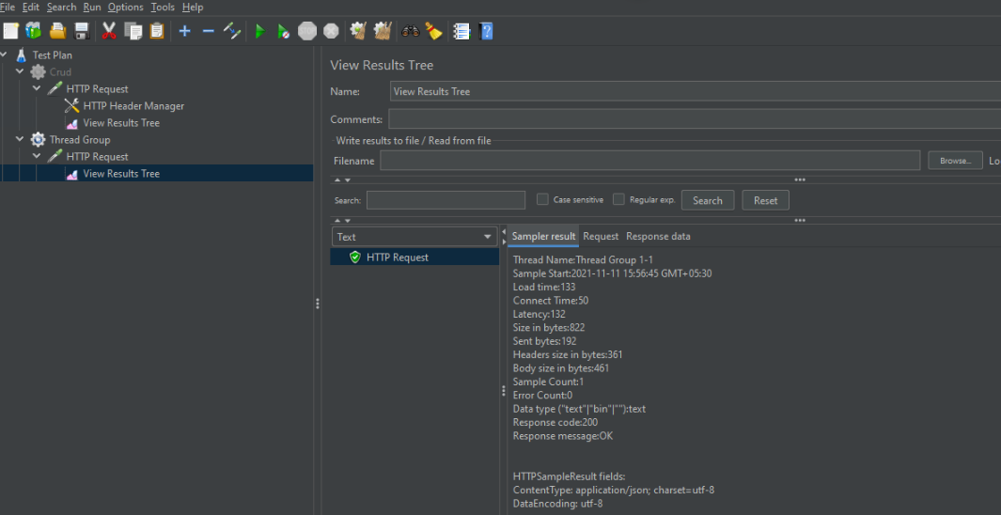

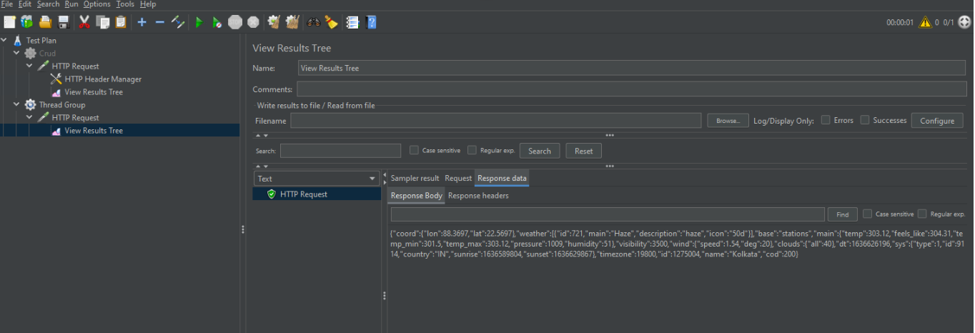

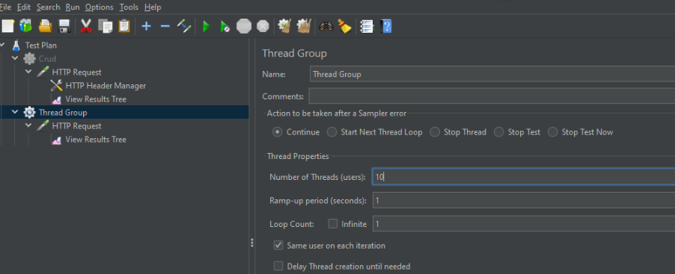

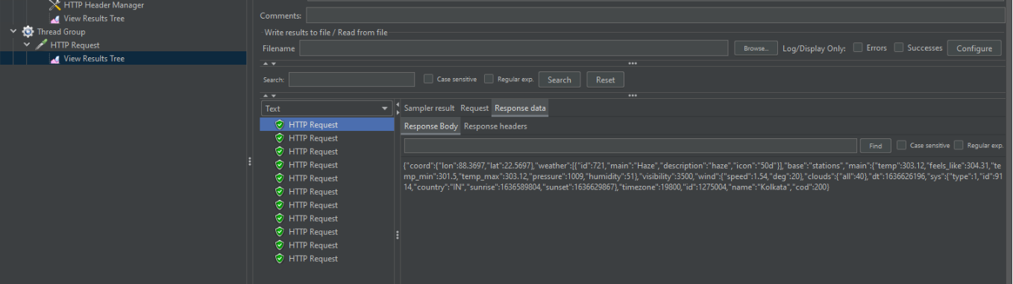

* Checking how much load that our API can handle.

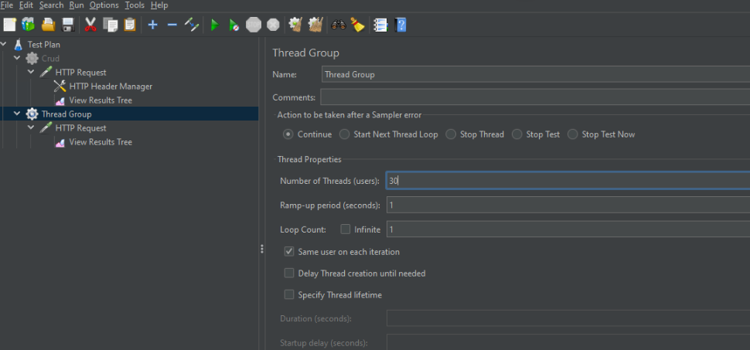

* The below result shows that API can handle 30 Threads without any problem.

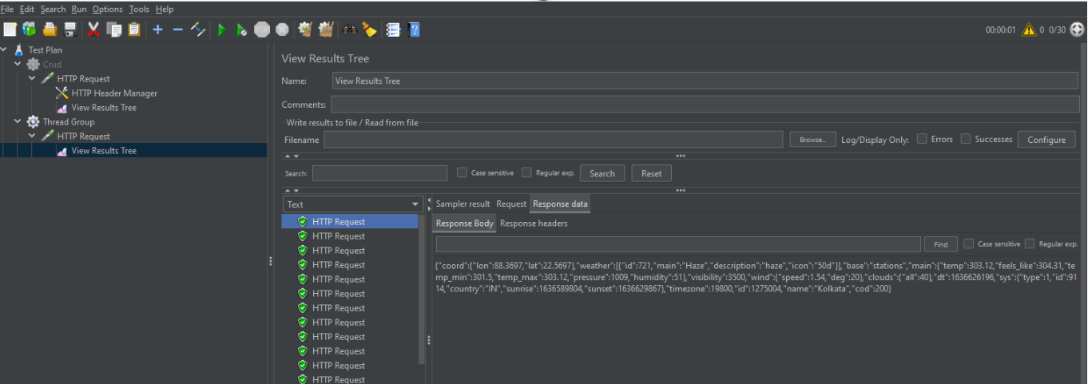

* Adding Assertions
* Add 🡪 Assertions 🡪 Response Assertion.

